Seashore ecommerce site

# current State

Our online ordering system was created by Pro*Act many years ago utilizing the technology available at the time.

The site shows its age with lack of functionality, appeal and ease of use by the customer.

## Customer presentation

The ecommerce site is linked from our website under the “Order Online” button. The customer is taken to a [eservices.proactuse.com](https://eservices.proactusa.com/oebeta/login.aspx?memberno=X015) page where is presented with a login window. After the credentials are entered the customer is presented with the order entry screen. If the customer has the ability to order for several destinations, he/she will be presented with a dropdown menu where the destination will be selected.

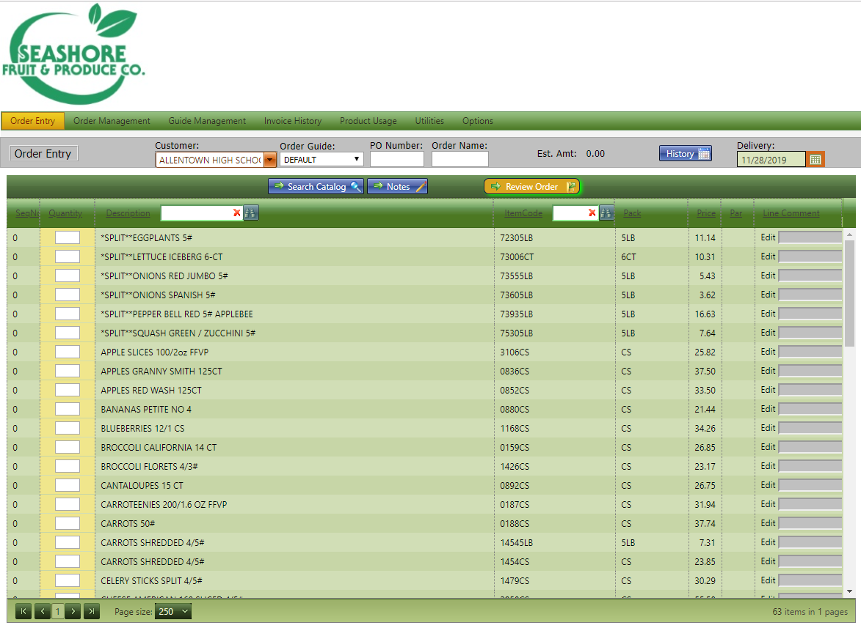

This screen shows the order guide selected, a field to enter a PO number and an order name. The history button shows a calendar with orders.

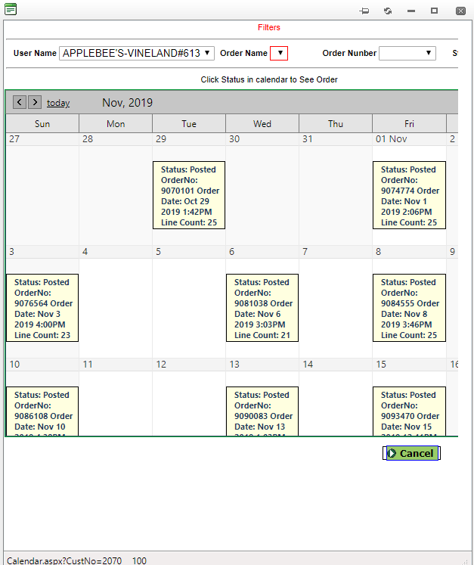

From the top menu the customer can access the order management. The system will show all the orders placed between a set of days that can be selected at the top of the window.

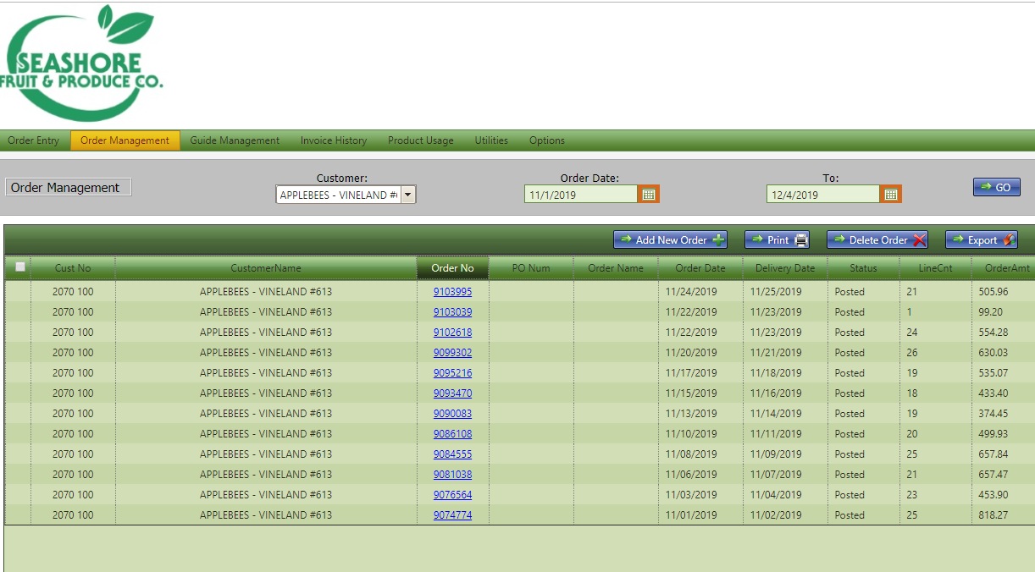

From here the customer can access individual invoices or, by pressing “add new order” is taken back to the main page. The status of the order is either “posted” or “open”.

### shortfalls

* Customer is presented with open and posted orders but they can’t see orders that already have been invoiced or paid.
* There is no direct connection to pay invoices from the order management.
* Awkward submit button. Not pressed in the correct sequence may affect the order submission.
* There is no information about the product

## Site Management

The management site is similar to the customer view with the difference of additional menus such as utilities.

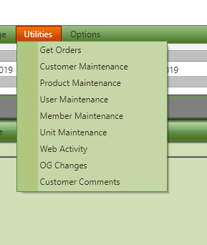

From this menu is access get orders, customer maintenance, product maintenance, user maintenance, member maintenance, unit maintenance, web activity, OG charges and customer comments.

#### Get Orders

The manager is presented with a table of orders, with the status of “Open” ahead of the rest.

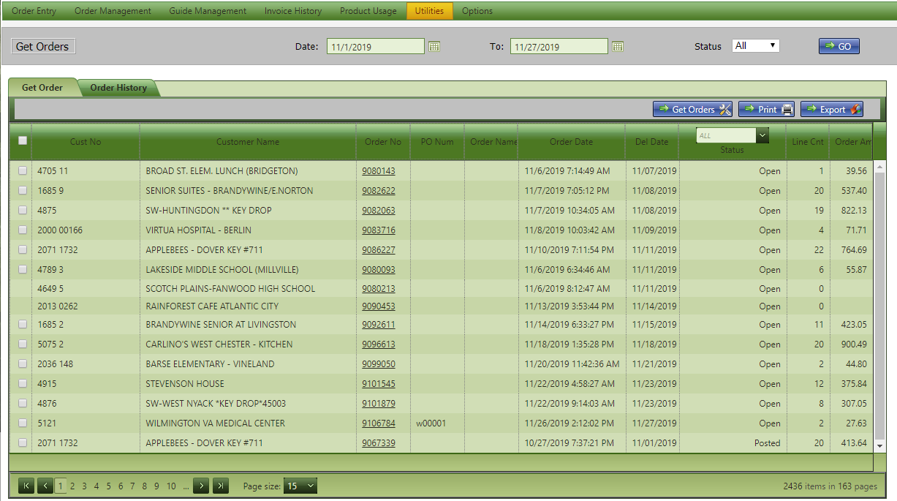

Orders can be selected and by clicking on the “get Orders” button a send orders are presented with options to send the order via email or FTP.

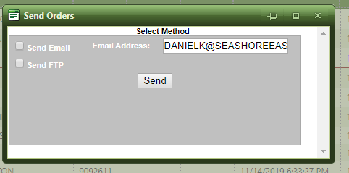

#### Customer Maintenance

The customer maintenance screen presents the manager with the list of customers active in the web site. There are search boxes by customer number and by customer name.

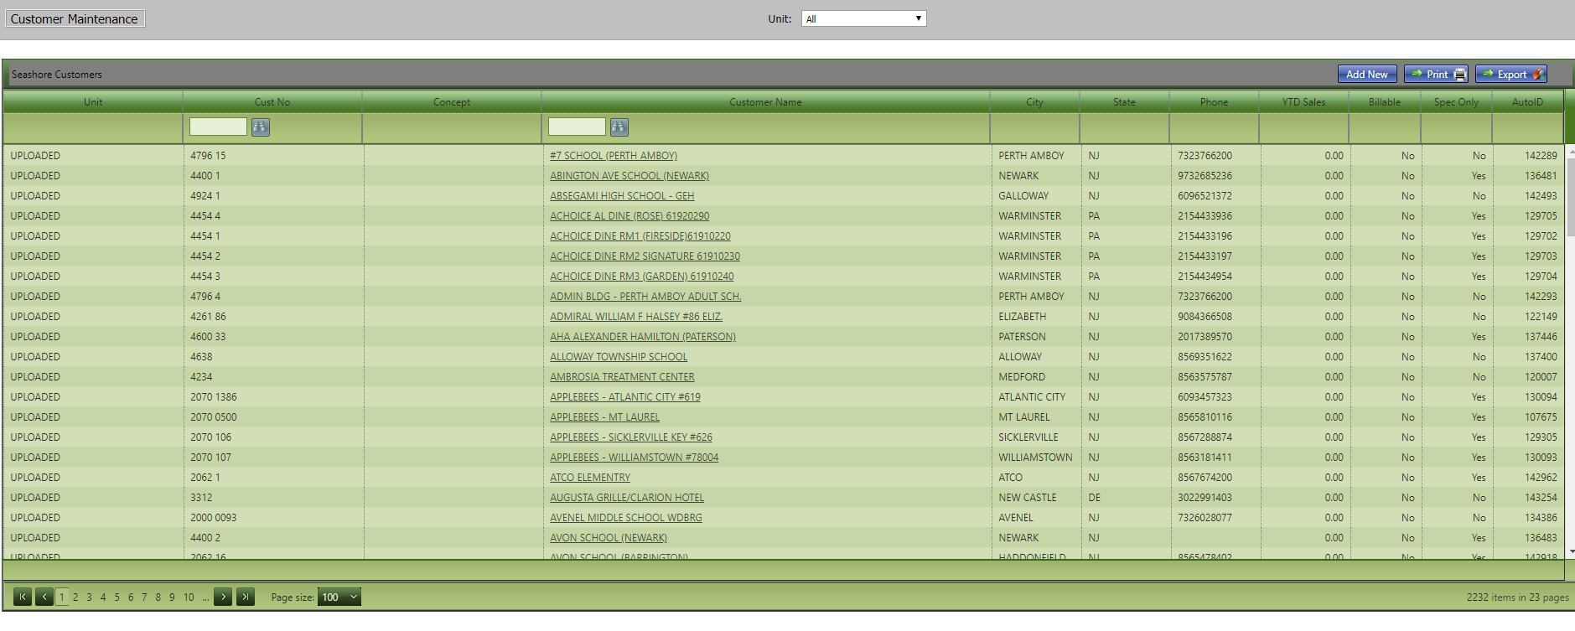

By selecting a customer, we are presented with customer information entry.

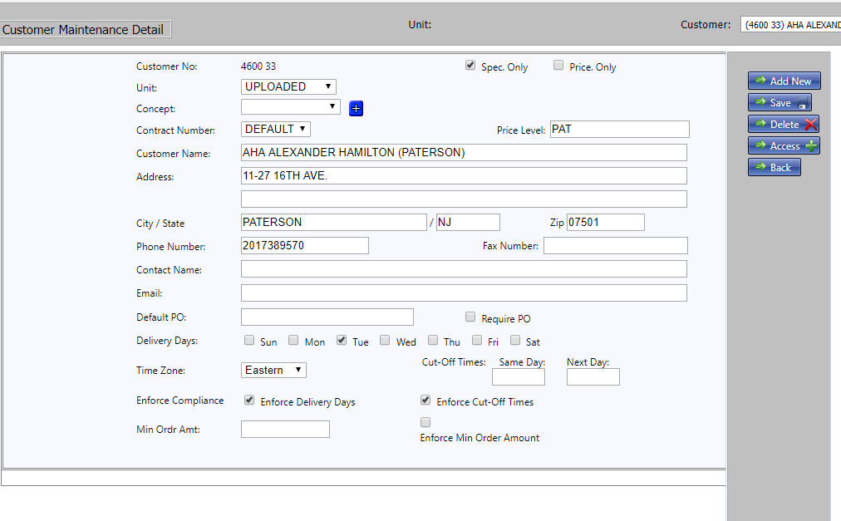

#### Products Maintenance

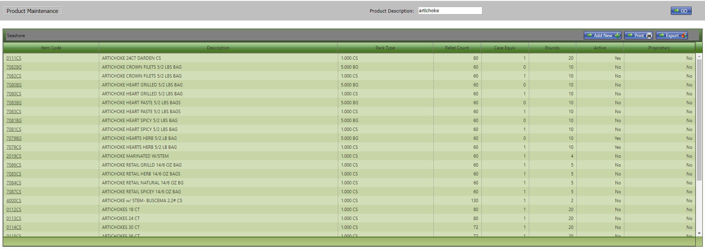

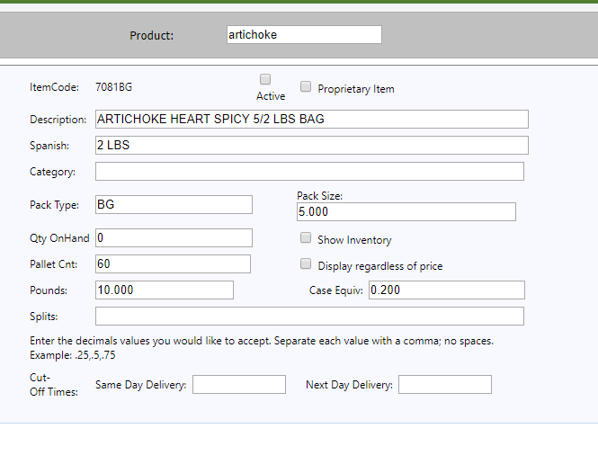

#### User maintenance

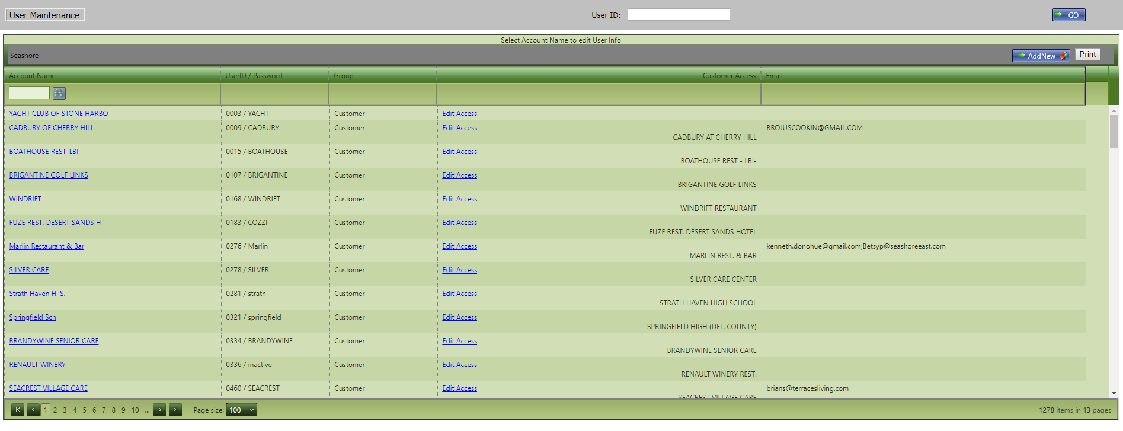

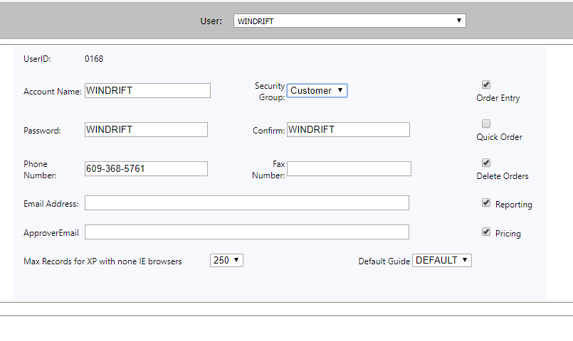

#### Member Maintenance

Member maintenance is the setup of our company in the Pro*Act ecommerce.

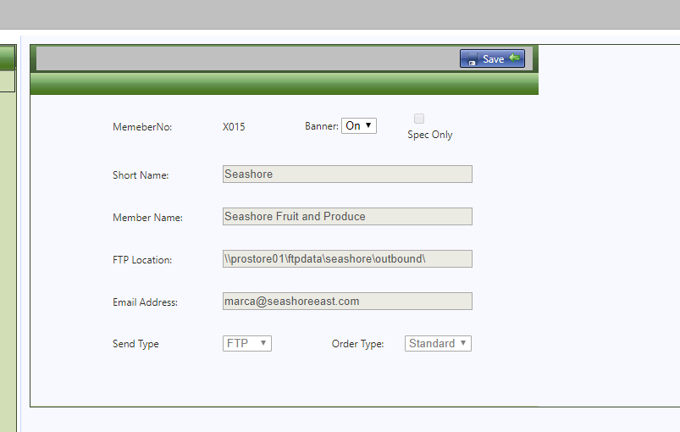

#### Unit Maintenance

Here the name of the ordering group is maintained.

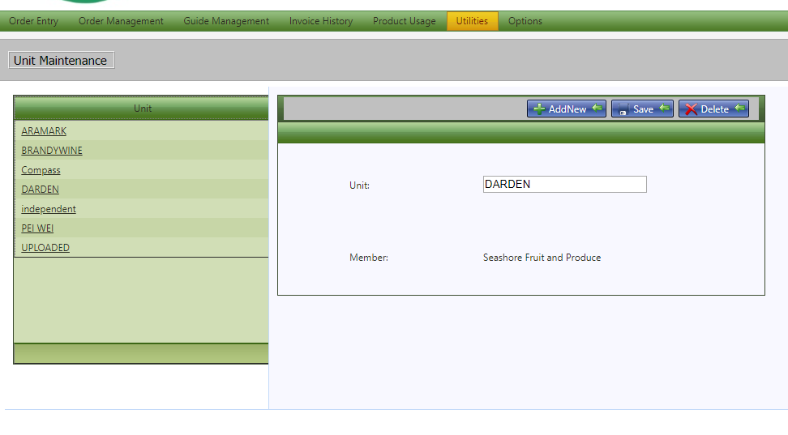

#### Web Activity

Doesn’t seem to be working.

#### Order Guide Changes

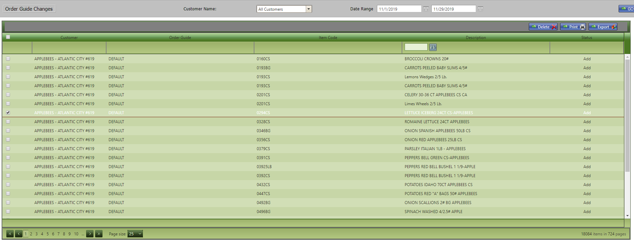

#### Customer Comments

Shows all customer comments made in the ecommerce site.

### shortfalls

* Site does not allow for customer impersonation to be able to see exactly what the customer sees.
* This is a static site, there is no possibility to add “In Season” items or specials.

# Pro*act development

Pro*Act is pushing for a mobile interface with the ecommerce site. This seems to be a dedicated app that can run on a tablet or smart phone. We do not have many details on this solution.

Pro*Act said in a conversation with Erwin Albizu, that they are working on a complete redesign of the ecommerce site. Erwin said that he will get us a highlight of the functionality of the system shortly, but there are no dates for its implementation.

## Highligths

To be determined.

## shortfalls

* In my opinion one of the main shortfalls is the lack of independency from a “fit all” site and the ability to make changes to suit our customers. We are depending on Pro*Act to make changes as they have to evaluate the impact on other Pro*Act members.

# Seashore Development

Our on development will create a site that is tailored to our customers. We can make the site work in the way that individual customers want to work.

Most sites, of similar line of business, have a “on line” ordering button or similar that takes you to their ecommerce site.

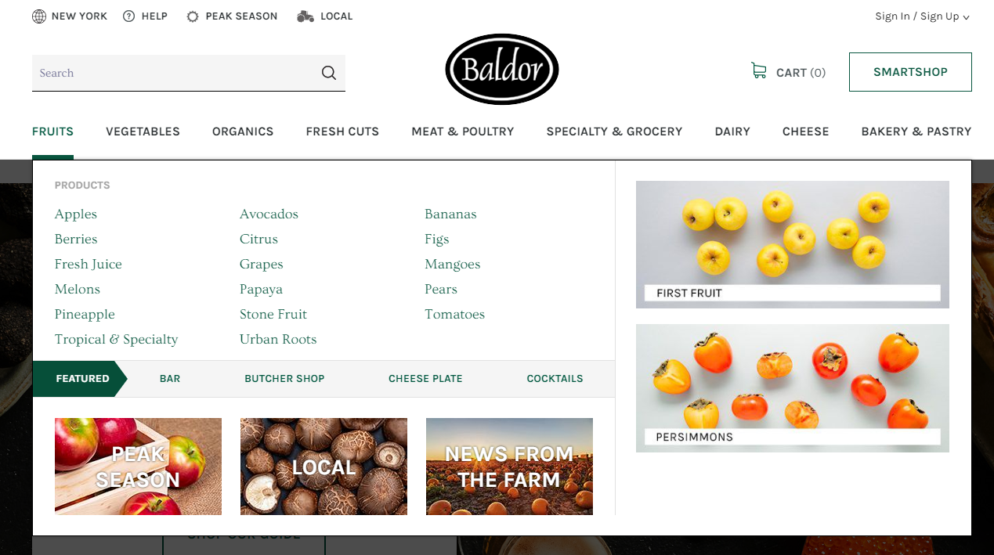

In the sample above the customer is presented with the main categories of their line of business. The customer has easy access to the cart, which holds the last order not processed or current order. Within the cart there is access to orders history including paid and pending orders. In the case above there is a Smartshop” button that sends you to a custom guide to speed up the process on repetitive orders.

The below sample is from a company called FreshDirect. Here they have a carousel showing highlighted products in the category.

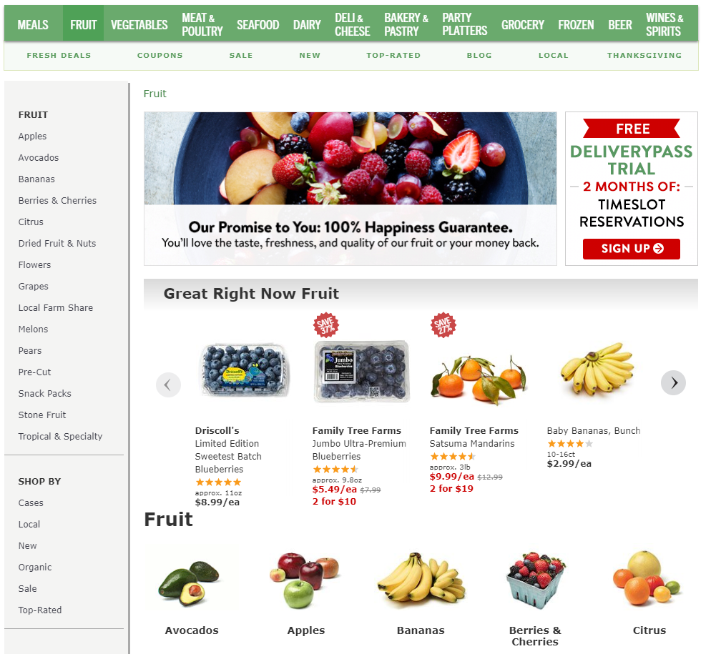

By hovering on a category, the customer is presented with a pop-up menu to select a type of product from that category. If customer clicks on the category, the customer is taken to a page with all available items within that category.

By clicking on one of the items the customer is presented with the available selection and a quantity selection and “add to cart” button.

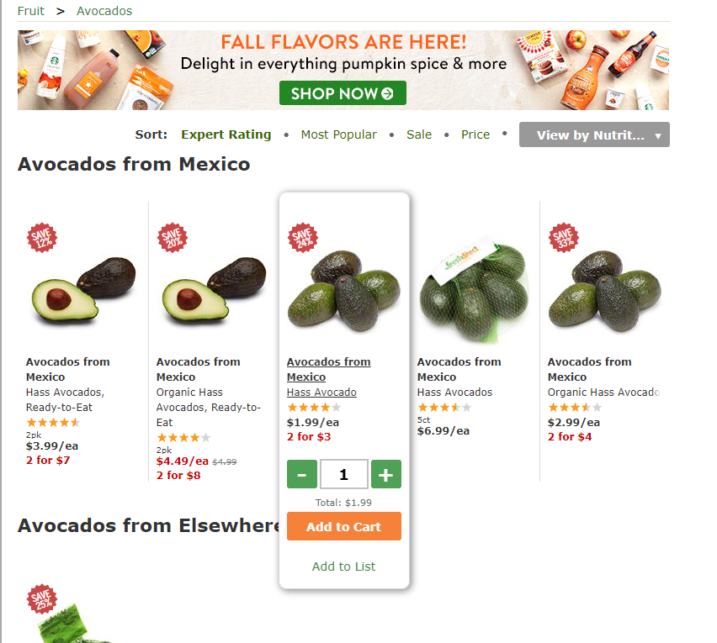

Baldor has a similar presentation with filters on top of the page to narrow down the options

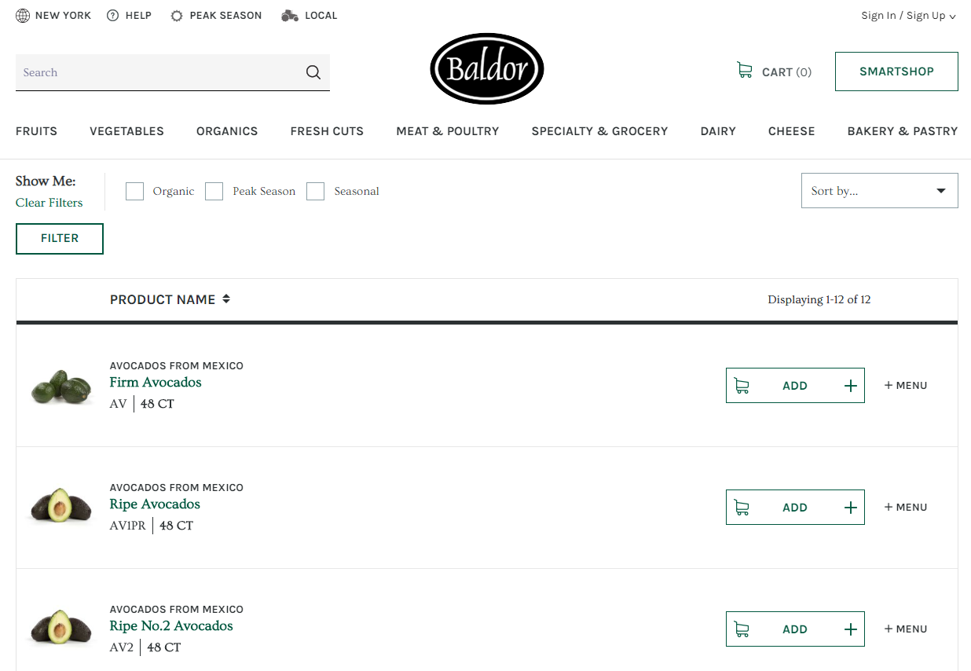

By clicking on a product, the customer is taken to a page for that particular item, where they can find more detail information about the product.

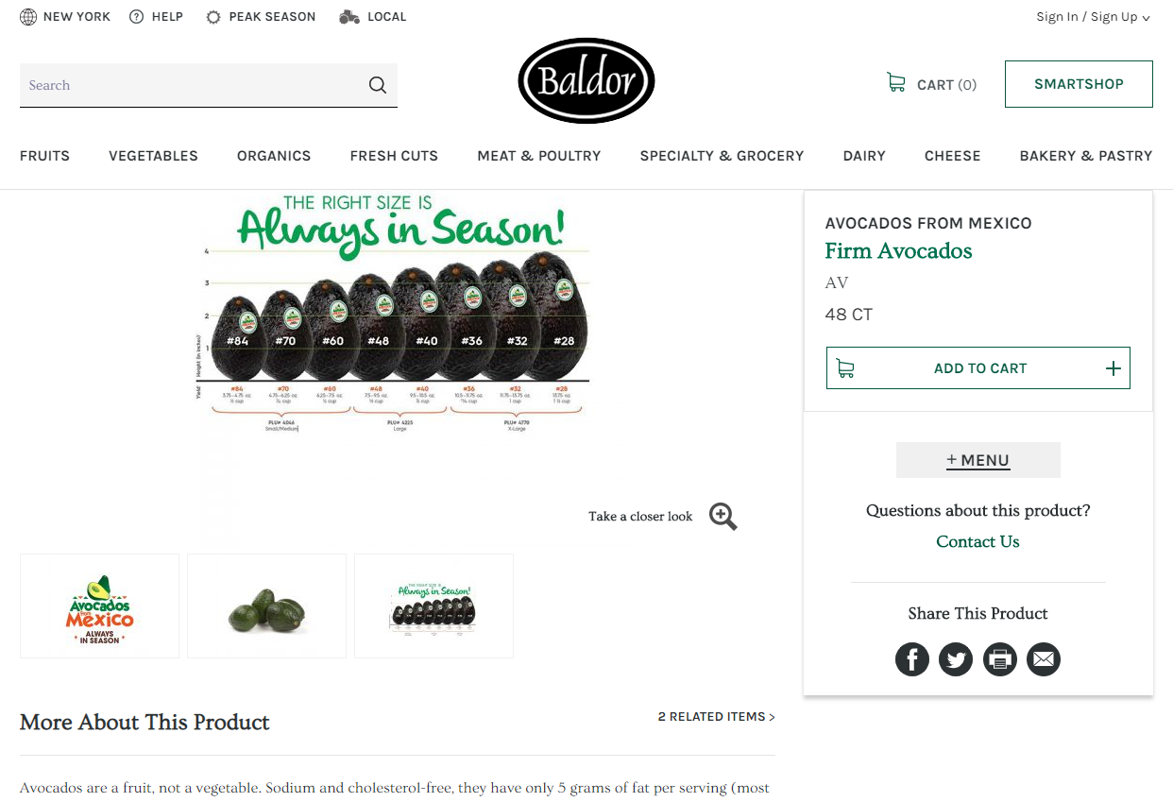

Note the amount of information that is provided to the customer, including the PLU number of the fruit depending on the size. There is a link to “Avocados from Mexico”, as in this example, that brings the customer to a page with details about the farm that grows the product and links to order products from that farm.

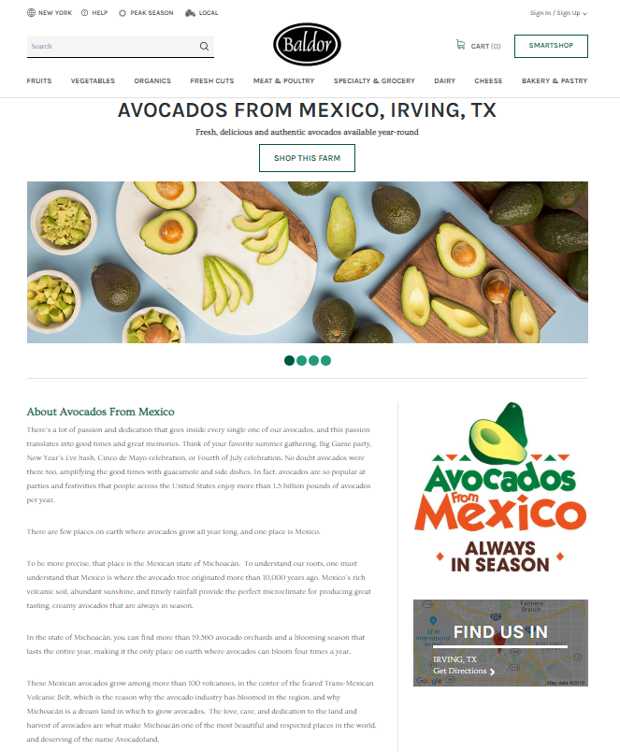

In some sites products that are not available are taken out of the catalog, as other sites the selection is presented to the customer as “View Similar” as in the case of Baldor’s web site.

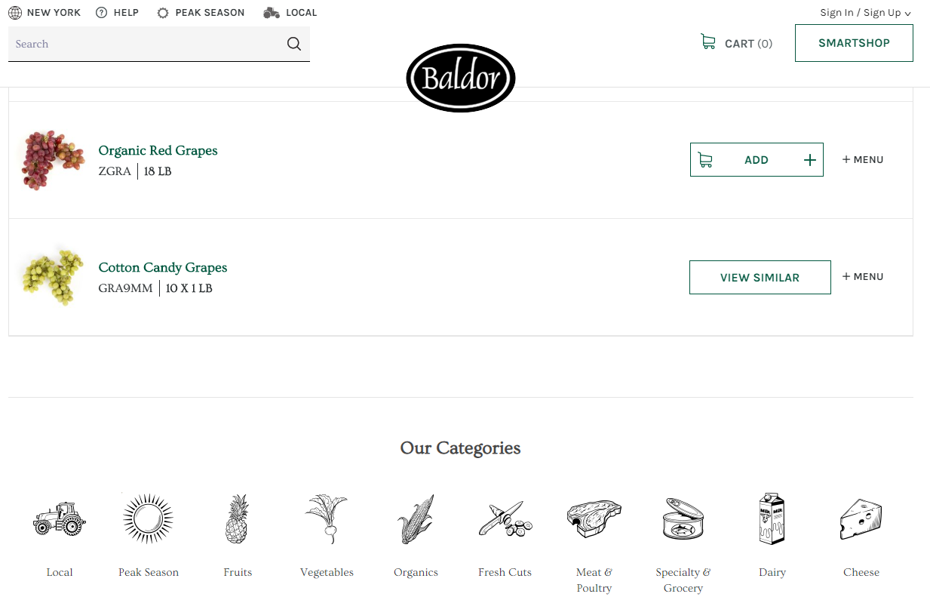

## Customer highlights

* Show custom catalog from Thyme to the customer. Allow to primarily order from that catalog, but allowing for broader selection from our main catalog.
* Search master catalog for particular product.
* Show a carousel with the “in season” or “specials” products to the customer.
* Show a “related” product as customers make selection from either their catalog or the master catalog.
* Allow customers to upload their orders. Simplifying the ordering process.
* Show customers the status of their orders. Placed – submitted – shipped – invoiced – paid.
* Receive automated emails with order status.
* Show the customer product usage by day, month, etc.

## Management highlights

* Customer impersonation. For troubleshooting purposes.
* When order is places the system will send notifications to a group.
* Need a easy to use translation interface for matching customer codes with ours.

## Website details

This is the guide for the development of the site.

### Functionality

##### Access

Web site access by invitation only. Customers are created from the upload from Thyme. The system will detect new customers.

* Send customer an invitation via email.
* Verify customer email.
* Send Customer Service and the sales person an email when the customer has logged in the first time.

##### Presentation

###### Calendar

Our current system has a calendar showing the dates where orders were placed and pending orders. Is this a useful feature for the customer? Does the customer use this option?

###### Uploads

Customer order uploads facilitates the order entry for customers that centralize purchasing for many locations. The system is flexible to allow for different formats.

* Customer coordinates with CS and sends a copy of the format that they are using.
* IT will map product codes with our codes and ship to with our ship to.
* Needs facility to test the upload without affecting the current orders.

###### Customer support

We need to provide with a customer support facility to send emails from the system or a chat window that connects to customer service.

##### Order Windows

Customers have a cutoff window. Orders placed after the cutoff will be delivered the

### Technical Details

##### Customer Maintenance

* Authorized to upload. This field signal that we have successfully tested the upload document and the customer can start uploading their orders.

## Estimated cost

### Server

The server will run on a cloud service such as Vultr or Digital Ocean. I think a 140-160GB storage space will be sufficient to run our site, with an additional 140GB for backup. The services above offers a 24/7 uptime with full technical support.

* The cost for this service is about $50/Month.

### Development

I have talked to a couple of developers and because of the interaction between our ecommerce and Thyme would be more costly to adapt a prepackaged system than to create a system from a skeleton and adapt it to suit our needs.

The most important aspect of the system is that has to be written utilizing modern tools and data repositories. My recommendation will be that we utilize Laravel (a PHP Framework) and MySQL (a common relational database). In this manner we have control of the code and we are not dependent on a person or company.

* The ball park for developing the system is in the range of $10 to $15k.